|  |
| --- |
| letterhead heading.jpg |
|  |

# Technical Memorandum

To: Jane Tsong, Watershed Conservation Authority

From: Eric Stein, Katie Irving – Southern California Coastal Water Research Project

Re: Analysis of Temperature Patterns in the Los Angeles River

**Objective**

The goal of the LA River temperature monitoring was to characterize temperature patterns in various reaches of the river to better understand the relationship between temperature and the ability to support aquatic species of management or restoration concern. This work builds on the result of the LA River Environmental Flows Study, which focused on the relationship between flow modification and probability of aquatic life use beneficial uses being supported. Ultimately, the results of this monitoring can support future modeling and analysis to better understand how future changes in water temperature may affect the ability to support key species or habitats of management interest.

**Approach**

Temperature was measured continuously at seven locations in the Los Angeles River (Figure 1) using Onset tidbit data loggers at 30 minute intervals. The majority of loggers were placed on 20th August 2021, however the start date and the period of time deployed varied per site (see Table xx). Monitoring locations fell into two broad categories, vegetated sites with higher flows and less vegetated sites with lower flows. Comparison of patterns between these two categories of sites provides an opportunity to gain insight into the influence of vegetation and flow on temperature.

Figure xx: Map of logger locations

Table xx: Temperature logger sites, coordinates, logger numbers with start and end dates of time series. Data gap column states the number of days missing from the time series. Type refers to stream type determined.

|  |  |  |  |  |  |  |  |  |  |
| --- | --- | --- | --- | --- | --- | --- | --- | --- | --- |
| Site Name | Latitude | Longitude | Logger | Start Date | End Date | start date | End Date | Data Gap | Type |
| Willow Street | 33.80468 | -118.20548 | 21150064 | 4/21/22 | 5/31/22 | n/a | n/a | n/a | Concrete |
| Riverfront Park | 33.98585 | -118.17122 | 21150065 | 4/21/22 | 5/6/22 | n/a | n/a | n/a | Concrete |
| Lower Compton Creek Site | 33.84266 | -118.2052 | 21150075/21150070* | 8/20/21 | 9/29/21 | 4/21/22 | 5/31/22 | 204 days | Concrete |
| Steelhead Park | 34.0869 | -118.22796 | 21150074 | 8/20/21 | 11/30/21 | n/a | n/a | n/a | Vegetated |
| Benedict Street | 34.10112 | -118.24217 | 21150073 | 8/20/21 | 11/30/21 | n/a | n/a | n/a | Vegetated |
| Rattlesnake Park | 34.10824 | -118.25251 | 21150077 | 8/20/21 | 11/30/21 | 1/20/22 | 5/30/22 | 51 days | Concrete |
| Burbank Blvd | 34.17045 | -118.47727 | 21150068 | 8/20/21 | 10/20/21 | n/a | n/a | n/a | Vegetated |

*Logger replaced

Summary of analysis

* Temp metrics - Max, min, mean daily temp, 7 day rolling mean & max, diurnal temp rate (difference between min and max daily)
* Air temp sourced from NOAA - LA downtown gage
* Regression – linear model for sites separately and for stream type separately. Only max daily temp analyzed so far.
* Diurnal rate – boxplots of sites, stream types and seasons (data gaps in seasons)

**Key Findings**

1. What is the range of observed temperatures and how do they relate to ranges necessary to support key aquatic species?
   1. Table summarizing data using different temperature metrics
   2. Relate ranges to tolerance ranges for spp (Table or box plots)
   3. Compare observed ranges to those reported by Abdi et al

Table xx: Mean temperature (°C) variables for all sites compared to species tolerance ranges and Abdi et al 2022.

|  |  |  |  |  |  |  |  |  |  |  |
| --- | --- | --- | --- | --- | --- | --- | --- | --- | --- | --- |
| Site Name | Max Temp | Mean Temp | Min Temp | DTR | Min 7 Day Mean | Max 7 Day Mean | Steelhead | Typha | Willow | Abdi et al 2022 |
| Burbank | 25.07 | 24.23 | 23.38 | 1.69 | 24.35 | 25.19 |  |  |  |  |
| Rattlesnake | 22.96 | 20.27 | 17.41 | 5.55 | 20.05 | 22.75 |  |  |  |  |
| Benedict | 23.01 | 21.32 | 19.15 | 3.86 | 21.38 | 23.07 |  |  |  |  |
| Steelhead | 22.38 | 21.32 | 20.06 | 2.32 | 21.38 | 22.45 |  |  |  |  |
| Riverfront | 30.24 | 21.70 | 15.92 | 14.31 | 21.84 | 31.37 |  |  |  |  |
| Compton | 21.63 | 20.43 | 19.45 | 2.18 | 20.05 | 21.28 |  |  |  |  |
| Willow | 29.08 | 21.51 | 16.45 | 12.62 | 21.42 | 28.95 |  |  |  |  |

1. What is the relationship between air and water temperature and how does this vary by stream condition?
   1. Regression analysis of air temp vs. water temp for the different stream classes

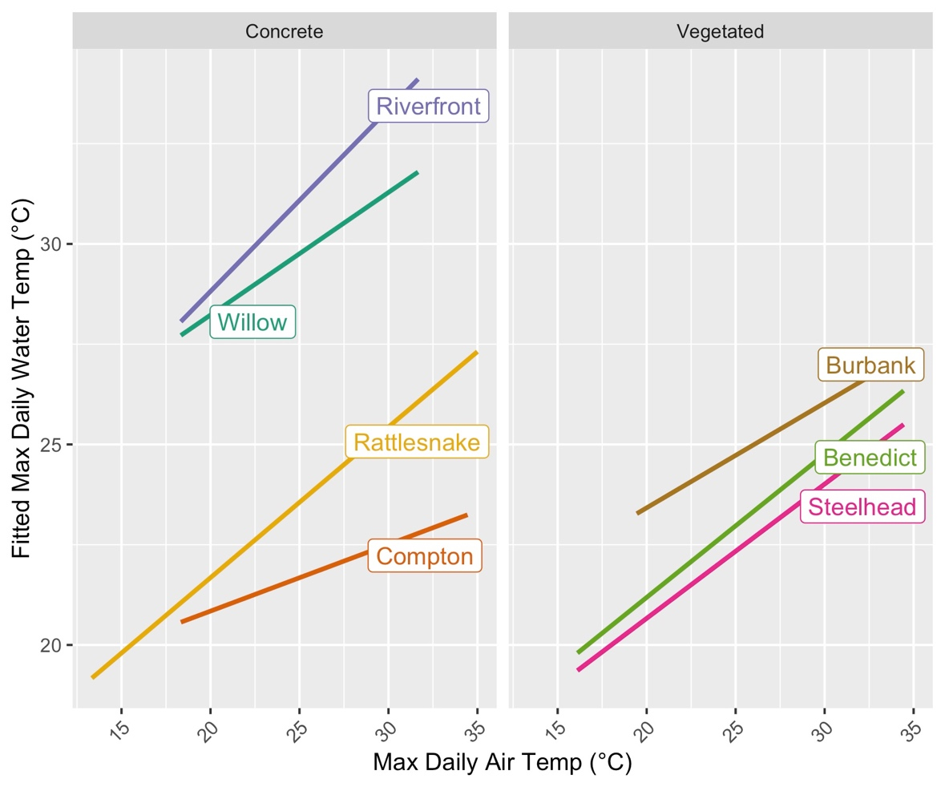

Figure xx: linear regression of max daily water temperature as a function of max daily air temperature for each site, separated by stream type.

Figure xx: linear regression of max daily water temperature as a function of max daily air temperature for each stream type.

Table xx: Air temperature and daily max water temperature linear regression coefficients for all models: sites and stream type.

|  |  |  |  |  |  |  |  |
| --- | --- | --- | --- | --- | --- | --- | --- |
| Site | *r2* | *p* | *n* | Stream Type | *r2* | *p* | *n* |
| Benedict | 0.28 | 0.06 | 103 | Vegetated | 0.26 | 0.04 | 268 |
| Burbank | 0.21 | 0.07 | 62 |  |  |  |  |
| Steelhead | 0.25 | 0.06 | 103 |  |  |  |  |
| Compton | 0.09 | 0.06 | 78 | Concrete | 0.09 | 0.05 | 363 |
| Rattlesnake | 0.25 | 0.04 | 230 |  |  |  |  |
| Riverfront | 0.16 | 0.28 | 16 |  |  |  |  |
| Willow | 0.20 | 0.10 | 39 |  |  |  |  |

1. How do diurnal and seasonal patterns vary as a function of stream type
   1. Bar or box plots of diurnal ranges by stream type
   2. Bar or box plots of seasonal ranges by stream type

Figure xx: diurnal rate per site coloured by stream type.

Figure xx: Diurnal rate by stream type.

Figure xx: diurnal rate by season and stream type.

Recommendations and Next Steps

Initial findings can be supplemented by continued monitoring of the existing sites and addition of sites in major tributaries of different sizes and configurations.

Temperature patterns can be compared to depth, velocity, and functional flow metrics previously calculated for the monitored reaches to better elucidate the relationship between temperature, hydrology and hydraulics, relative to the needs of focal species of interest

Supporting material

Figure xx: time series of temperature metric per site

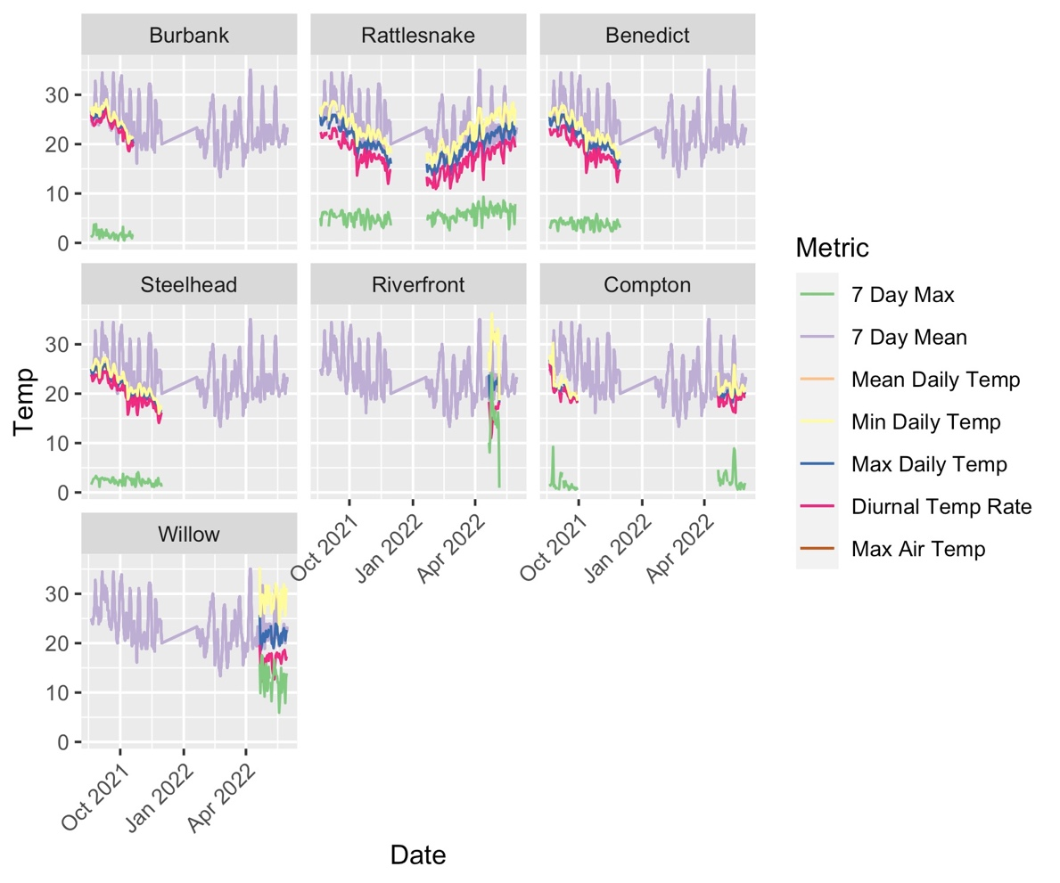

Need to fix this one!!!!